Lab 2 Reflection

1. Student Information
Name: Zachary Mayers
Student Number: 000769443
Lab Number: Lab 2

2. Lab Status

Working
- Lab 1 source code is stored in a GitHub repository with all secrets removed.
- The application is deployed to Azure App Service (Free F1 plan) and is publicly reachable.
- The database is hosted on Azure SQL Database.
- Roles (Supervisor, Employee) and both seeded users are created on startup, using passwords read from configuration instead of the code.
- Login and logout work for the seeded users, and the Companies list loads from the Azure database.
- The app was published in Release mode and runs in the Production environment, so detailed error pages are not shown to users.

Not Working / Known Issues
- The first deploy failed with HTTP Error 500.30 (app failed to start). This was caused by two problems: the connection string was added under App settings instead of Connection strings, and the free Azure SQL database was paused when the app first tried to connect. Both are fixed and the site is running (see Section 4).
- The free Azure SQL database auto-pauses when idle, so the very first request after a long idle period can be slow or fail until the database wakes up. Adding EnableRetryOnFailure to the UseSqlServer call lets the app retry instead of crashing.

3. What I Learned / Need to Work On
- How .NET configuration works. User secrets, appsettings.json and environment variables all feed into one combined configuration. The code just asks for a key like ConnectionStrings:DefaultConnection and does not care where the value comes from. That is what lets the same code use user secrets locally and Azure settings in production without any changes.
- Deploying and troubleshooting on Azure. I learned how to set up an App Service and Azure SQL Database, and how to debug a 500.30 error by running the app manually in the Kudu console to see the real exception. I also learned that Azure exposes Connection strings and App settings differently, and that nested keys use a double underscore (SeedUsers__SupervisorPassword) in environment variables.
- Keeping secrets out of source control. Using a proper .gitignore, checking git status before every commit, and starting the repo fresh so no old commits contain passwords. Something I still need to work on is configuring Data Protection key encryption, since Azure logged a warning that keys may be stored unencrypted.

4. Screenshots (Running on Azure)

Use Case: Visitor views the home page
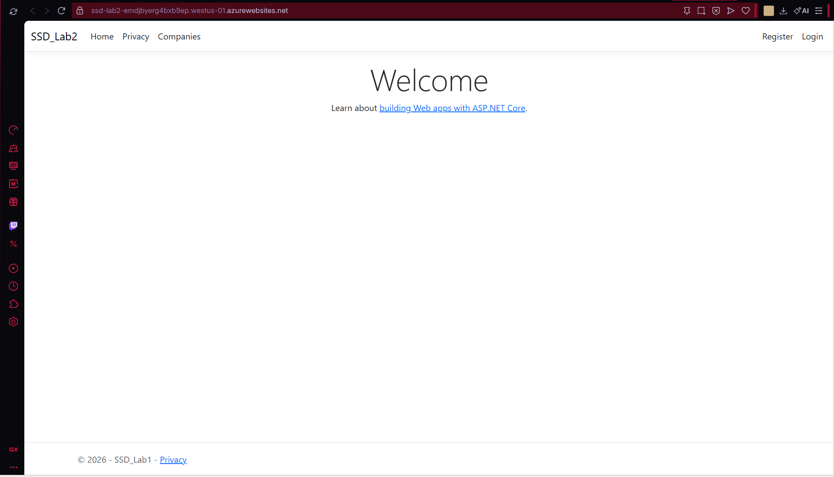
Home page loaded from the Azure URL while logged out.

Use Case: Supervisor logs in
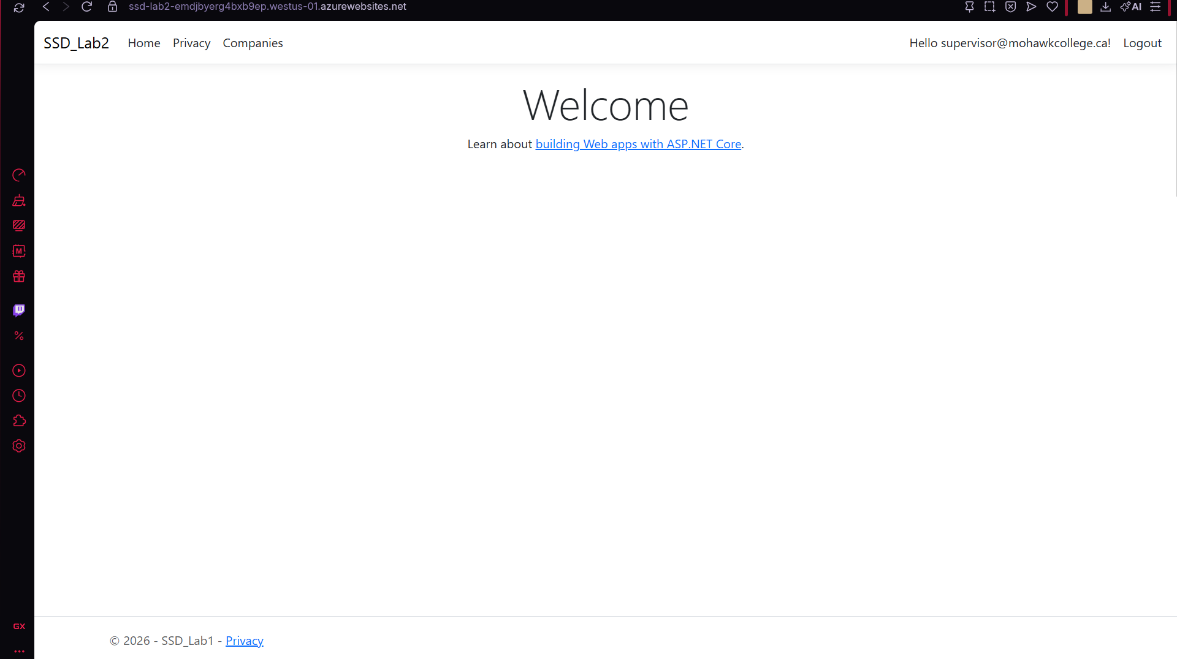
Logged in as supervisor@mohawkcollege.ca, a user seeded into the Azure SQL database on startup.

Use Case: Supervisor views the Companies list
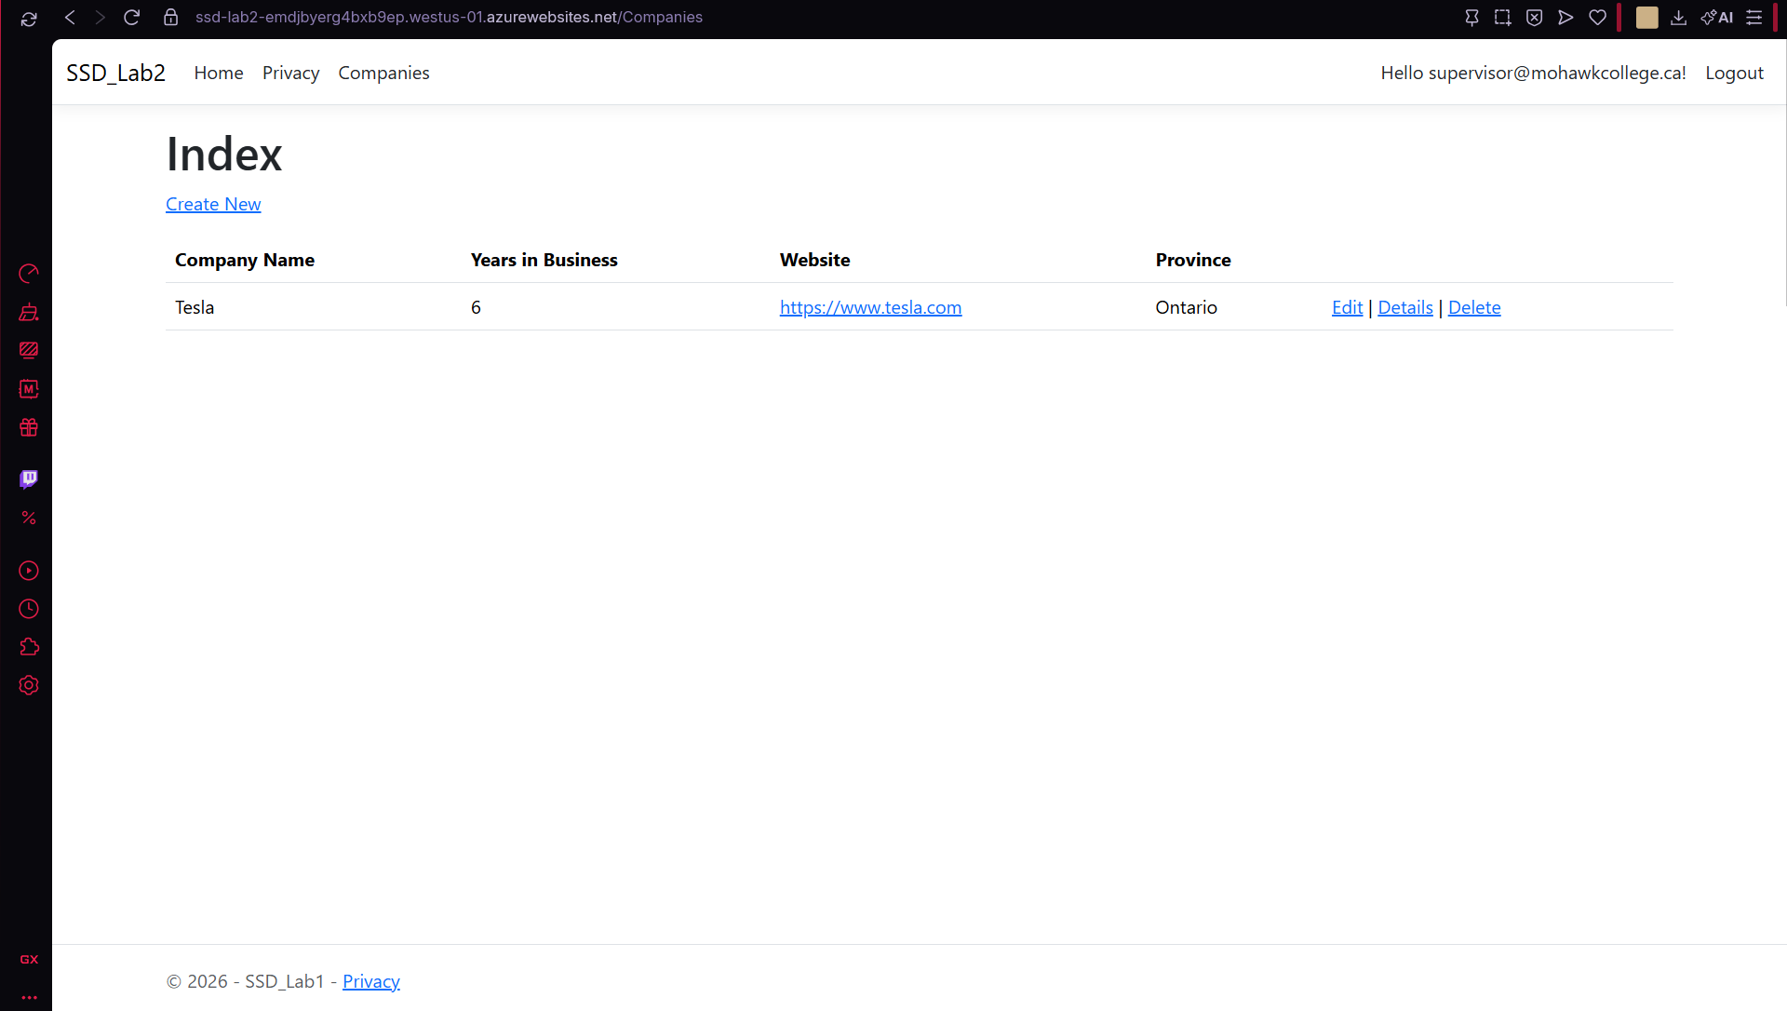
Companies page reading data from the Azure SQL database.

Problem Encountered: App failed to start (500.30)
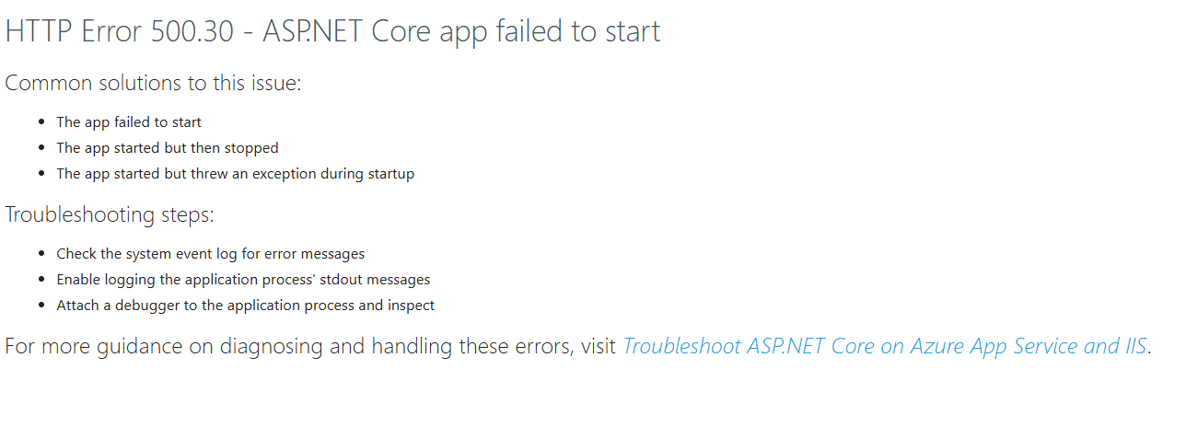
First deploy failed. Fixed by moving DefaultConnection to the Connection strings tab and letting the paused database resume.

5. Links
Source code repository: https://github.com/zachnodes/SSD_lab2
Deployed site: https://ssd-lab2-emdjbyerg4bxb9ep.westus-01.azurewebsites.net

6. Vulnerabilities and Leaked Secrets
- Hardcoded seed user passwords. DbSeeder.cs had the supervisor and employee passwords written directly in the code. I replaced them with configuration lookups (SeedUsers:SupervisorPassword and SeedUsers:EmployeePassword). Locally they come from user secrets, and on Azure they are App settings.
- Connection strings in appsettings.json. The DefaultConnection and ApplicationDbContext connection strings were stored in appsettings.json, which gets committed. I moved them into user secrets and left the values empty in appsettings.json. The production connection string, which includes the database password, only exists in the Azure App Service Connection strings settings.
- Files that should not be committed. The first git add tried to include the .vs folder because there was no .gitignore. I added the standard .NET .gitignore so .vs, bin and obj are excluded. I also removed my Lab 1 reflection document from the commit, since it contains my student number and does not belong in the repository.
- Old commit history. Removing a secret from a file does not remove it from earlier commits, so the repository was started fresh after the secrets were removed.
- Detailed error pages. The app is published in Release mode and runs in the Production environment, so users see a generic error page instead of stack traces that could reveal code or configuration details.

7. Login Instructions
URL: https://ssd-lab2-emdjbyerg4bxb9ep.westus-01.azurewebsites.net
Note: The free database pauses when idle, so the first load may take up to a minute. If an error appears, wait a moment and refresh.

Supervisor
Username: supervisor@mohawkcollege.ca
Password: Password!1

Employee
Username: employee@mohawkcollege.ca
Password: Password!1

